***Final Assembly [3.0]***

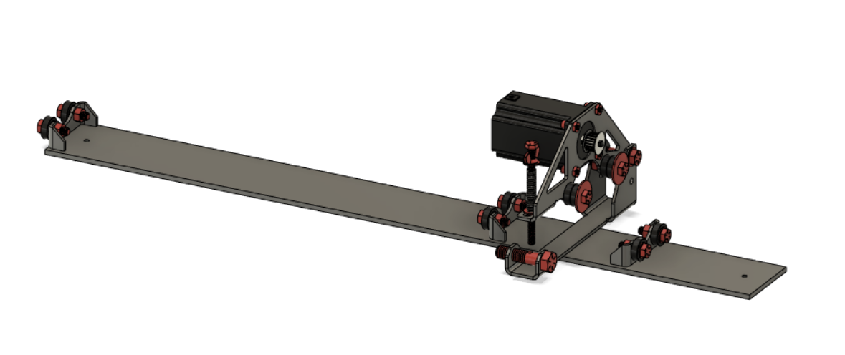

***Roller Mount [3.1]***

**Parts Needed**

**1x Base Mount (Plasma Cut)**

**1x 3/8” x 2” Bolt**

**1x 3/8” Nut**

**2x 3/8” Washers**

**1x 1/2” x 2” Bolt**

**1x 1/2” Nut**

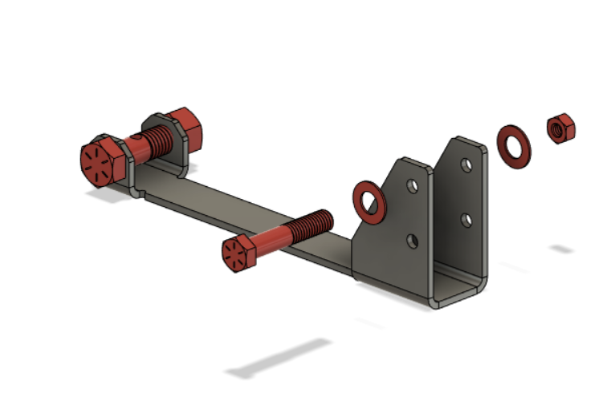

Drill out the two smaller holes to 3/8” and drill out the larger hole to 1/2”

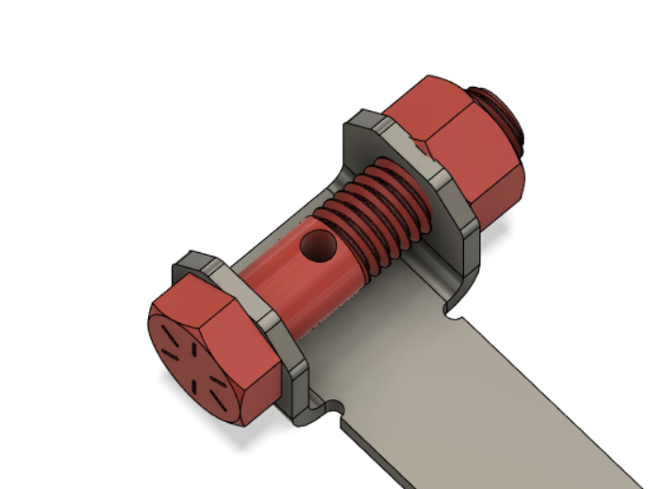

Drill and tap a hole for 1/4” - 20 Threads in the center of the 1/2” bolt

***Table Mount [3.2]***

**Parts Needed**

**1x Assembly [3.1]**

**3x Bearing Mounts**

**1x 3” x 30” x 3/16” Flat Bar**

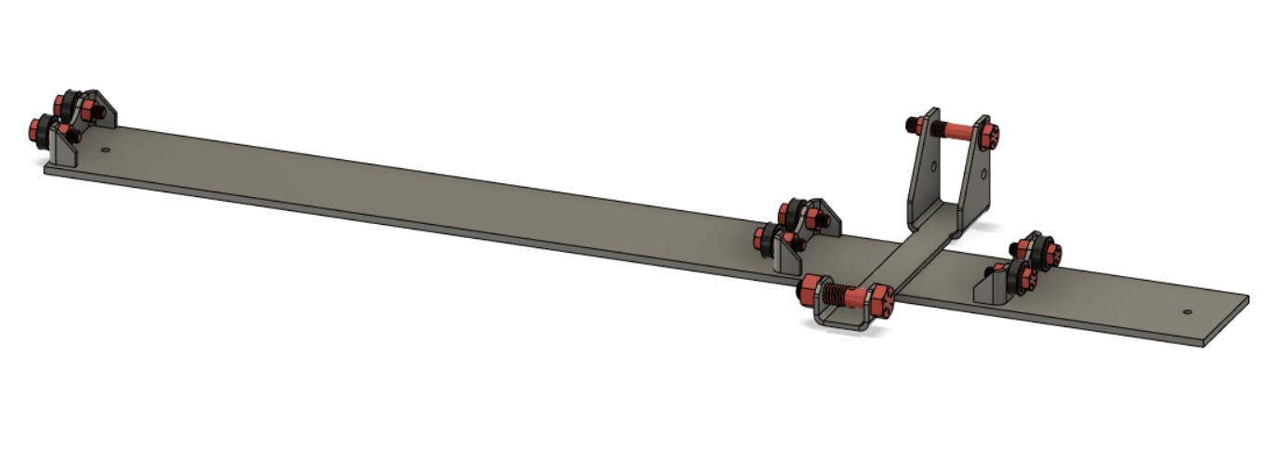

Weld parts onto the flat bar

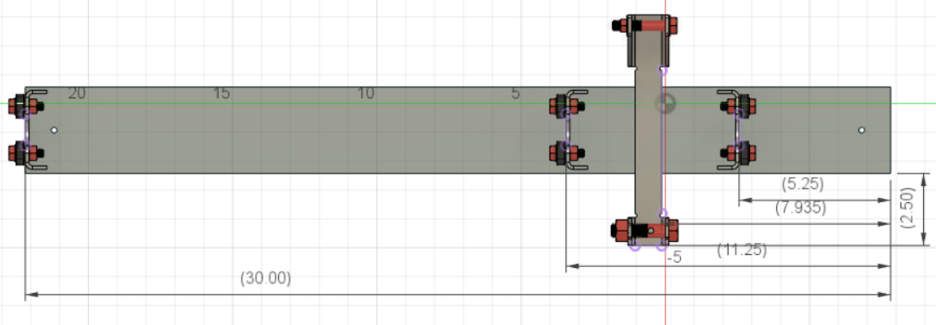

This is a reference for the spacing on the parts, this can be changed to your liking if you choose.

***Finishing Up [3.3]***

**Parts Needed**

**1x Assembly [3.2]**

**1x Tube Roller**

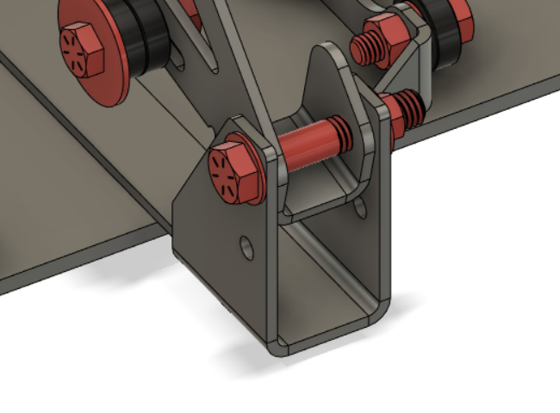

Attach the tube roller to Assembly [3.2] as shown, the second hole is used for adjustment of different tube sizes.